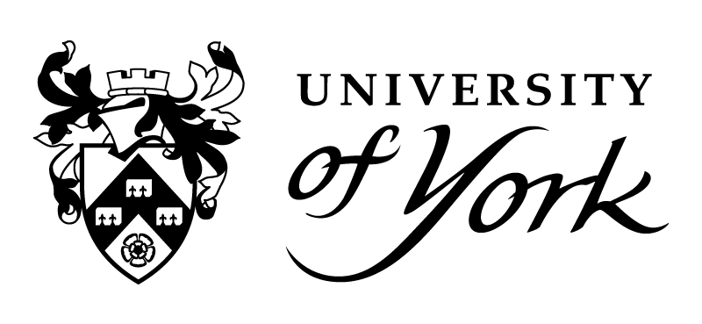
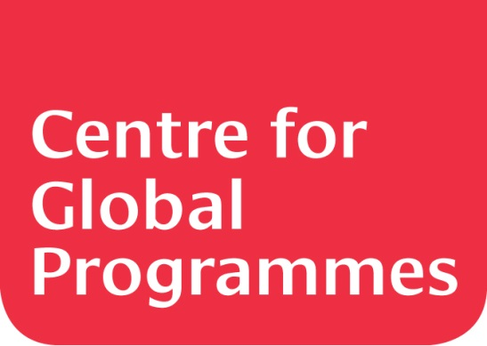

Global Economics and Politics
Summer School

1 – 12 August 2017

Programme information

Programme Aims
This summer school aims to develop your knowledge of some of the key themes in global economics and politics. Keynote talks from senior University of York academics will provide varied input which will be explored further through discussion and visits to iconic landmarks such as the Houses of Parliament and the Bank of England. This, along with the Critical Thinking component, will help you to deepen your insight into world affairs and ability to reflect on your experiences.

Programme structure
The programme is divided into six main components:

1. Keynote talks
The keynote talks will be delivered by senior academics in fields of Economics and Politics. These talks provide the foundation of the programme with the discussion sessions and the trips providing further exploration of the key themes.

2. Discussion
These seminar-style sessions usually follow the keynote talks and will allow you discuss the themes of the keynote talks in greater depth. You will be expected to contribute to discussion by asking questions, giving your opinion and developing a line of argument, as appropriate.

Topics could include: the EU, immigration, growing income inequality, pollution, sustainability and the environment, conflict and conflict resolution, epidemiology and health economics, the global banking system, climate change, the weakening of democracy, intensifying nationalism

3. Tutor sessions
These sessions will help you with the skills you need to participate in the discussions after the keynote talks a well as help you prepare for trips and the poster presentations.

4. Critical thinking
This component will help you to engage in reflective and independent thinking and will help you to understand approaches to problem solving expected in top class higher education institutions.

5. Trips
You will be going on several trips which are linked to the keynote talks. These will include London and Edinburgh.

6. Poster presentations
At the end of the two weeks you will prepare a poster presentation that will bring together your experiences on the programme. Your poster should demonstrate what you have learnt and how you have developed your knowledge of the key programme themes.

Course dates: 31 July – 11 August 2017

All-inclusive course fees: £1900
- Course fees includes:
- Pick up from airport of arrival
- Bus pass
- All travel and accommodation on campus in York and in London
- Weekend trip to London
- Day trip to Edinburgh
- Breakfast, lunch vouchers and most evening meals
- Social programme

Hours per week: 21.5

Level IELTS 6.0

