

Robotics and Artificial Intelligence Summer School for USTC and Fudan University

22 July to 9 August 2019 at Imperial College London, UK.

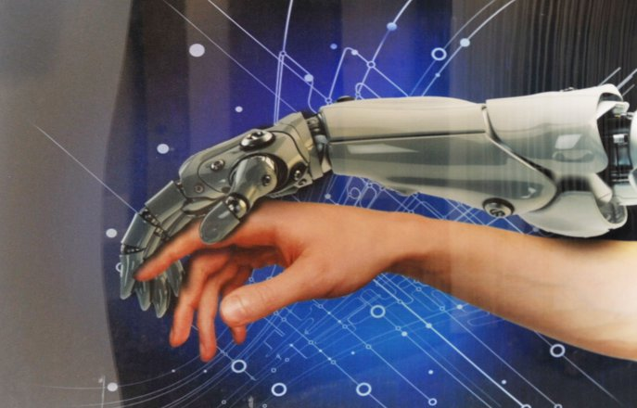

This three-week summer school is designed for students studying computer science, computing or software engineering, electronics engineering, mechanical engineering and other relevant engineering degrees in either the final two years of their undergraduate studies, at master level or first year PhD at a well-recognised university in China.

Students will:

- Gain an insight into Machine Learning, Robotics and Artificial Intelligence;
- Understand the latest real-world applications and innovations in these areas;
- Meet and hear from industry and academic experts on AI in High Performance Computing and Data Science and learn about the Challenges of the Internet.
- Develop valuable professional skills in business model innovation, communication and presentation;
- Work as a team on a project to create a robotic device and develop a business case towards a group competition;
- Visit London’s Silicon Roundabout Tech City;
- Practice and improve their English language.

In addition, students will have an opportunity to make new friends, get to know student ambassadors from Imperial College London through social activities and discuss opportunities for future study and experience what it is like to study in a world class university.

Programme Structure:

60 contact hours spread over 3 weeks covering lectures, workshops, tutorials, and project work.

Students will be allocated into groups and a project will be assigned to each group at the start of the programme working towards a project presentation on the last day of the programme.

There will also be cultural and social activities organised by Imperial student ambassadors.

The entire programme will be taught in English.

Certification:

Students will receive an Imperial College London certificate of attendance on successful completion of the programme. The winning group(s) will also receive an award of recognition.

Entry requirements:

All students are expected to be studying a computer science, computing/software engineering, electronics engineering, mechanical engineering, or other engineering related degree in in either the final two years of their undergraduate studies or at master level or first year PhD at a well-recognised university in China.

All students are required to have a good software programming skills, knowledge of MATLAB and good command of English and if it is not their first language, they will need to satisfy the College requirement as follows:

- a minimum score of IELTS (Academic Test) 5.5 overall (with no less than 5.0 in any element) or equivalent.
- CET-4 (China) minimum score of 550
- CET-6 (China) minimum score of 520

Teaching Faculty

The summer school is directed by Professor Guang-Zhong Yang, PhD, FREng, Director and Co-founder of the Hamlyn Centre for Robotic Surgery, Deputy Chairman of the Institute of Global Health Innovation, Imperial College London, UK. Professor Yang also holds a number of key academic positions at Imperial – he is Director and Founder of the Royal Society/Wolfson Medical Image Computing Laboratory, co-founder of the Wolfson Surgical Technology Laboratory, Chairman of the Centre for Pervasive Sensing. Professor Yang is also the Founder of UK Robotics & Autonomous Systems Network and hosted a visit to The Hamlyn Centre for President Xi Jinping during his state visit to the UK in October 2015.

The summer school will be taught by Professor Guang-Zhong Yang and his team from The Hamlyn Centre and the Department of Computing.

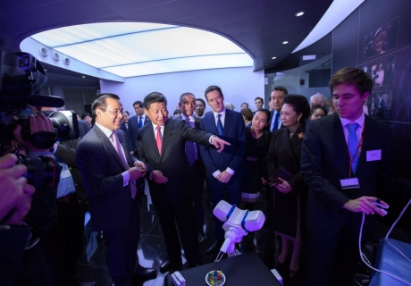
Photo above: Professor Guang-Zhong Yang showing President Xi Jinping one of his medical robotic devices.

Photos from 2018 cohort:

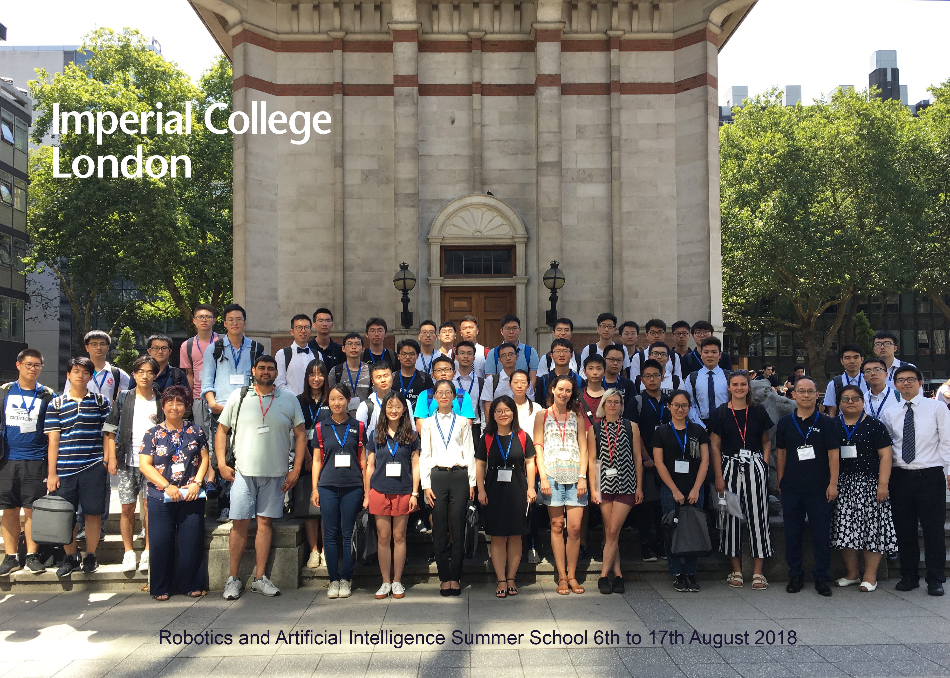

Above: 2018 summer school students group photo with Imperial ambassadors at Imperial College Queen’s Tower.

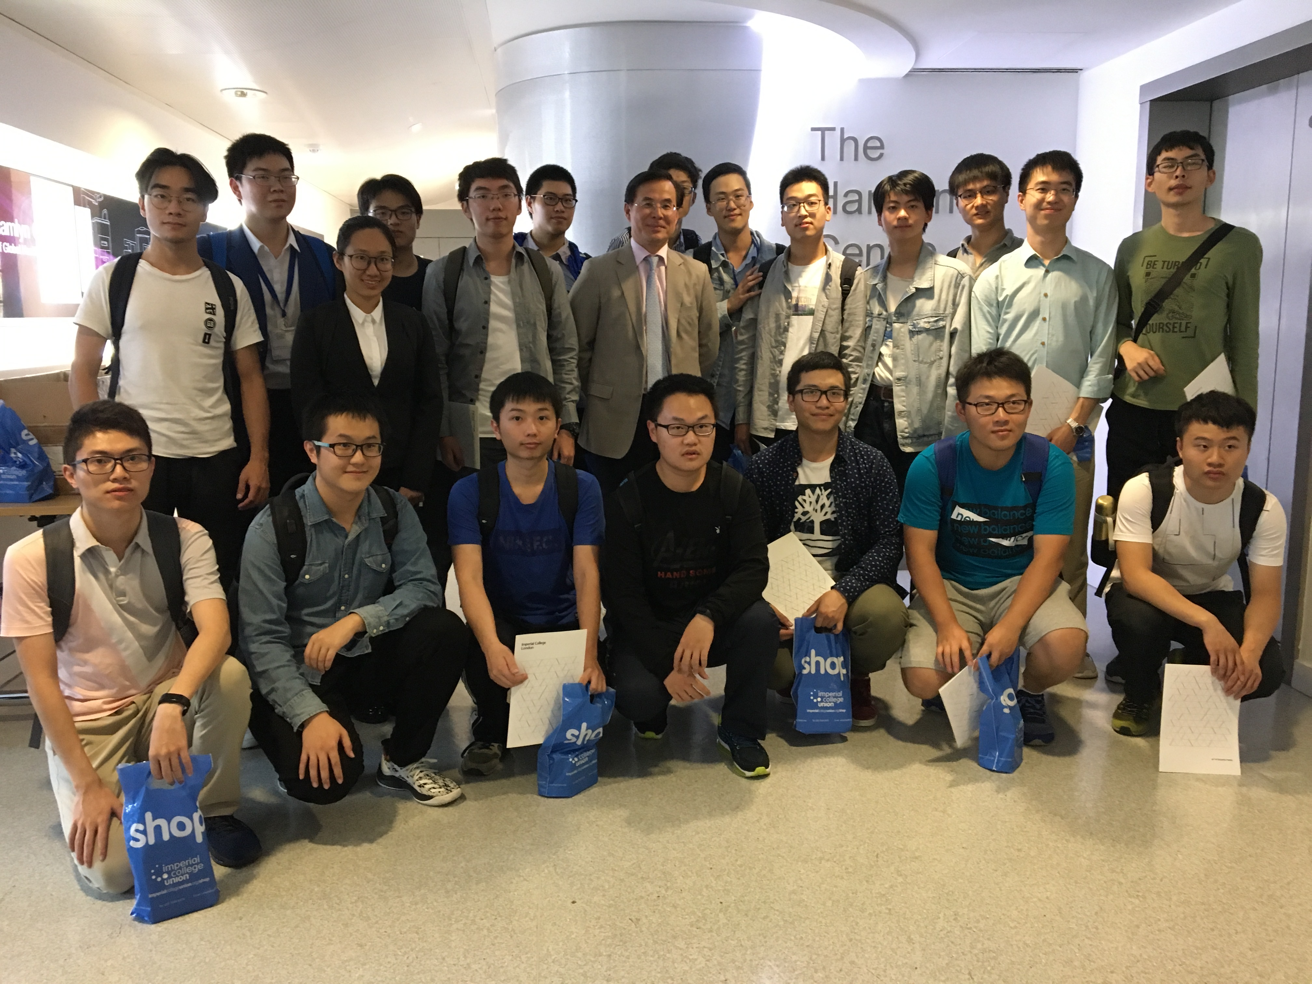

Above: Summer School students visiting The Hamlyn Centre for Medical Robotics
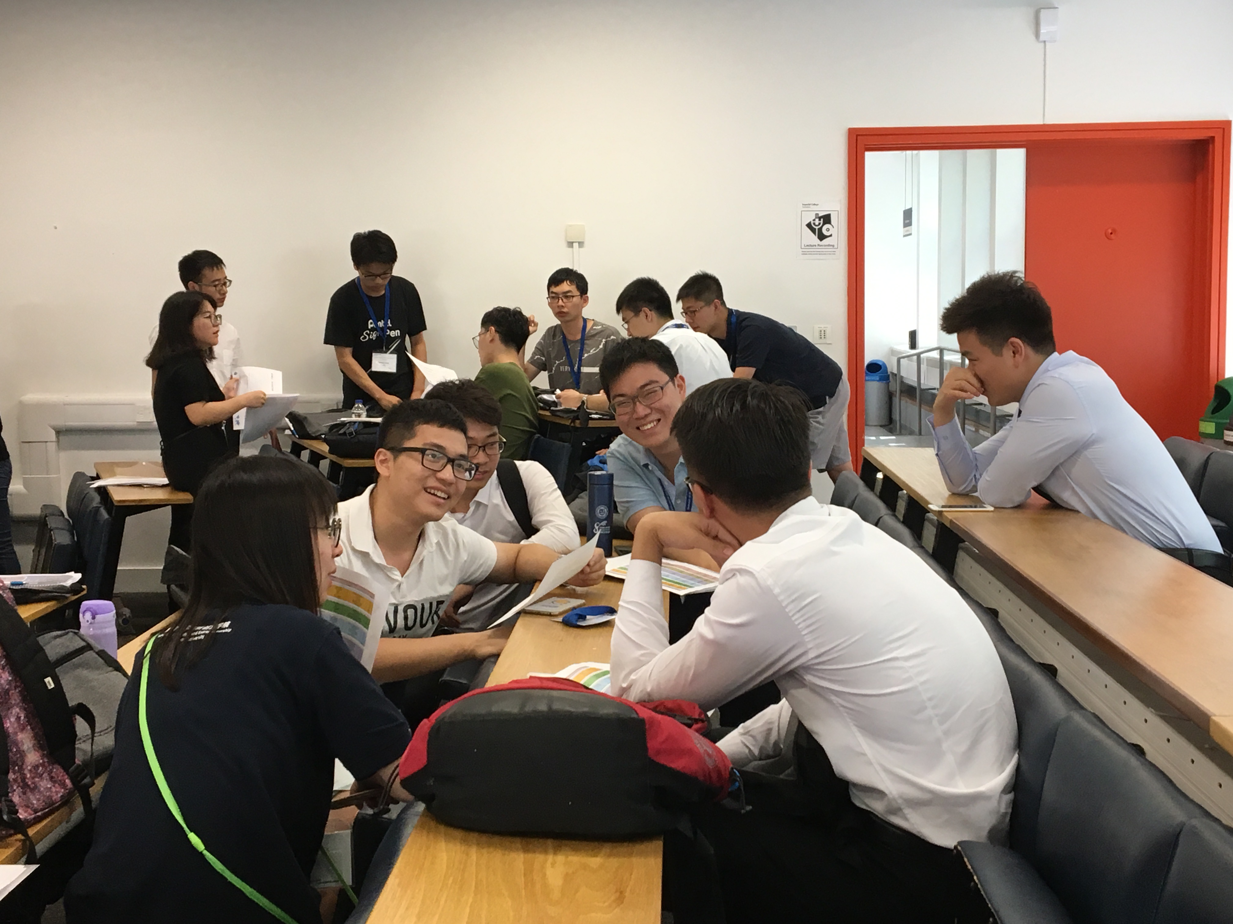

Above: 2018 students discussing in their teams.
Provisional timetable:

Week 1:
Monday 22 July
08:30 | Programme Registration
08:45 | Welcome and Introduction to Imperial
09:00 | Introduction ‐ Robotics and AI (1)
 | Introduction ‐ Robotics and AI (2)
 | Tutorial 1
12:00 | Introduction to Imperial Student Ambassadors/Group Photo
12:30 | Welcome lunch with student ambassadors
 | followed by Campus Tour
14:00 | Group Project Planning
16:30 | End of day
Tuesday 23 July
09:30 | Machine Learning ‐fundamentals (1)
 | Machine Learning ‐fundamentals (2)
 | Tutorial 2
12:30 | Lunch
13:30 | Group project supervision
15:30 | Travel to Westminster Pier for River Cruise
16:40 | Social sightseeing activity with student ambassadors
 | Thames River Cruise (Cruise depart at 16:40)
19::00 | End of day
Wednesday 24 July
09:00 | Artificial Neuronets (1)
 | Artificial Neuronets (2)
 | Tutorial 3
13:00 | Lunch
14:00 | Group project pitch and tutorial
16:30 | End of day
Thursday 25 July
09:30 | Probabilistic Reasoning (1)
 | Probabilistic Reasoning (2)
 | Tutorial 4
12:30 | Lunch
14:00 | Business Model Innovation
17:00 | End of day
Friday 26 July
09:30 | Deep Learning (1)
 | Deep Learning (2)
 | Tutorial 5
12:30 | Lunch
13:30 | Effective Communication for Presentation Workshop
16:30 | End of day
Saturday 27 July & Sunday 28 July
 | Free time to explore London

Week 2:
Monday 29 July
09:30 | Machine Vision and AI (1)
 | Machine Vision and AI (2)
 | Tutorial 6
12:30 | Lunch
13:30 | Group project supervision
15:30 | End of day
Tuesday 30 July
09:30 | Shape and Feature Recognition (1)
 | Shape and Feature Recognition (2)
 | Tutorial 7
12:30 | Lunch
13:30 | Group project supervision
16:30 | End of day
Wednesday 31 July
09:30 | Image sequence processing (1)
11:30 | Image sequence processing (2)
 | Tutorial 8
12:30 | Lunch
13:30 | Travel to Old Street Station
15:00 | Silicon Roundabout and Tech City – London Walking Tour
17:30 | End of day
Thursday 1 August
09:30 | 3D Vision and Shape from X (1)
 | 3D Vision and Shape from X (2)
 | Tutorial 9
12:30 | Lunch
13:30 | Group project supervision
16:30 | End of day
Friday 2 August
11:00 | Visit to the Hamlyn Centre
12:30 | Lunch
13:30 | Group project supervision
16:30 | End of day
Saturday 3 August & Sunday 4 August
 | Free time to explore London

Week 3:
Monday 5 August
09:30 | AI and High Performance Computing
12:30 | Lunch
13:30 | Group project supervision
16:30 | End of day
Tuesday 6 August
09:30 | AI in Data Science
12:30 | Lunch
13:30 | Opportunities at Imperial for International Students
14:30 | Group project supervision
16:30 | End of day
Wednesday 7 August
09:30 | Challenges of the Internet
12:30 | Lunch
13:30 | Group project supervision
16:30 | End of day
Thursday 8 August
10:00 | Presentation rehearsal - Group 1
10:20 | Presentation rehearsal - Group 2
10:40 | Presentation rehearsal - Group 3
11:00 | Presentation rehearsal - Group 4
11:20 | Presentation rehearsal - Group 5
11:40 | Presentation rehearsal - Group 6
12:00 | Lunch
13:30 | Group project supervision
16:30 | End of day
Friday 9 August
09:30 | Groups to finalise project presentation
12:30 | Lunch
13:30 | Students arrive for presentations setup
14:00 | Presentation - Group 1
14:15 | Presentation - Group 2
14:30 | Presentation - Group 3
14:45 | Presentation - Group 4
15:00 | Presentation - Group 5
15:15 | Presentation - Group 6
15:30 | Farewell reception with ambassadors
 | and panel to confer results
17:00 | Closing Ceremony & Announcement of winning team and prize giving
17:30 | Programme ends and students depart

Application form:

Surname

First Name

Name in Chinese

Date of Birth

University

Subject of study

Year of study
(i.e. undergraduate Year 2, Year 3, Master or Year 1 PhD)

English Proficiency
(Please provide proof of certificate or qualification)

Reason for applying

Contact Email address

Please send completed application form to Lynn Qiu (lynnqiu@ustc.edu.cn), Office of International Cooperation, USTC.

