Soongsil Exchange Student Scholarship (SESS) Program
The diversity that international exchange students contribute to our community enriches it immeasurably. We are committed to supporting outstanding international exchange students who choose SSU.
Award Type | Description | Value | Application Deadline
Housing Waiver | For international exchange students entering SSU and staying for a semester at apartment or Soongsil Residence Hall only available for double/quadruple occupancy | up to 1,150,000 Korean won | Spring: December 1  Fall: May 1
Peer Mentoring Program | For international exchange students who want to pass on their native language skills and culture to fellow classmates 96 hours/semester or 6 hours a week for up to 5 SSU students | 1,440,000 Korean won | Spring: December 1  Fall: May 1
Internship | For international exchange students who want to work in one of several offices on campus for a semester 160 hours per semester or 10 hours a week | 800,000 Korean won | Spring: December 1  Fall: May 1

AM I ELIGIBLE?
To be eligible, you must be an international exchange student from one of our partner universities and be eligible to study in Korea on a Korean study permit.
You must also submit:

An application
A copy of your transcript
A statement of purpose
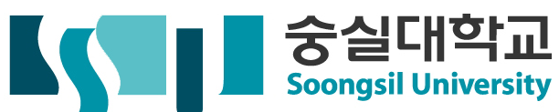
A letter of recommendation stating financial needs

