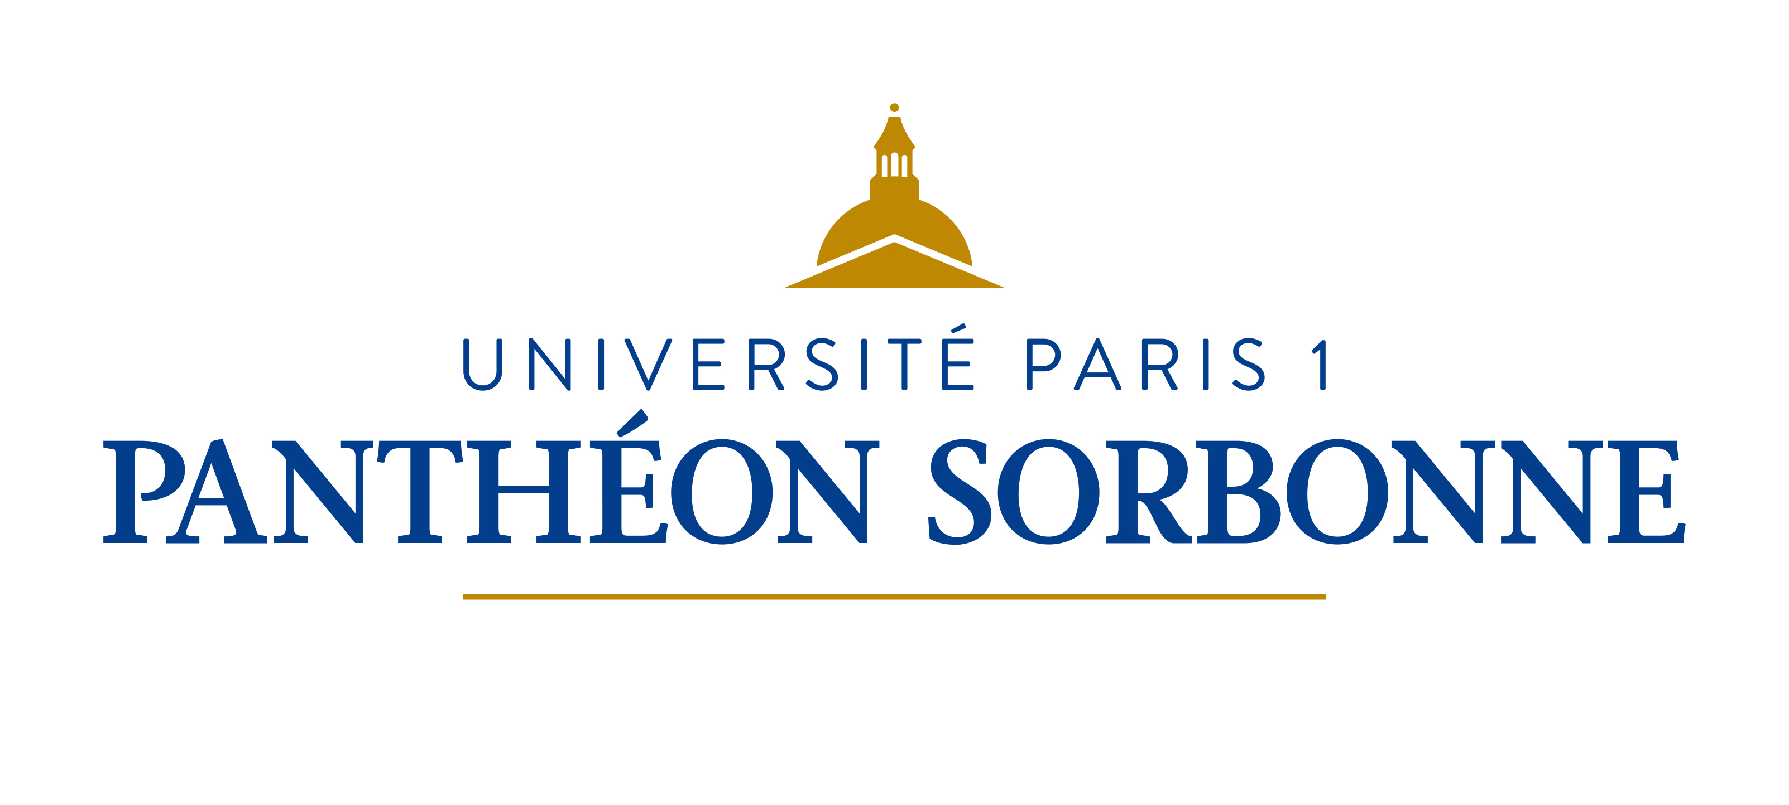

Fact Sheet for Erasmus+ KA107 International Credit Mobility students
Academic year 2018/2019

International Office
Université Paris 1 Panthéon-Sorbonne
Erasmus Code – EUC Number : FPARIS001
Address : Maison Internationale, 58 boulevard Arago, 75013 Paris
Telephone : 00 33 (0)1 44 07 75 37
Email : relinter@univ-paris1.fr
Website : https://www.pantheonsorbonne.fr/
Course Catalogue: http://www.pantheonsorbonne.fr/fr/international/etudiants-etrangers/candidature-en-echange-licence-master/liste-des-cours-ouverts-aux-etudiants-en-echange/

Mobility Office Contacts
Katrin Gebhard  Head of Mobility Office / Teaching Staff Mobility  00 33 (0)1 44 07 76 71  mobiliteri@univ-paris1.fr |  | Léa Dagher  Incoming Erasmus students / Incoming Erasmus trainees / Non-Erasmus exchanges  00 33 (0)1 44 07 76 75  incoming@univ-paris1.fr
Cécile Lafani  International Credit Mobility  00 33 (0)1 44 07 81 29  cecile.lafani@univ-paris1.fr |  | Philippe Larochette  Erasmus Bilateral Agreements / Accomodation contact person  00 33 (0)1 44 07 78 95  rimobilite@univ-paris1.fr  rilogement@univ-paris1.fr
Email for nominations : incoming@univ-paris1.fr
General Information
Academic Calendar
1st term: September 17th 2018 – January 19th 2019
2nd term: January 21st 2019 – May 16th 2019

Examination periods
1st term: January 7th 2019 – January 19th 2019
2nd term: May 2nd 2019 – May 16th 2019
(re-sit, if any: June 11th 2019 – June 28th 2019)

Nomination deadlines
1st term : June 15th 2018
2nd term : October 15th 2018

Application deadlines
1st term: June 30th 2018
2nd term: October 30th 2018
Language of courses  French | Recommended level for Bachelor / Master degree  B2/C1
Exchange related information
Orientation session for incoming students  Languages courses available to international students  Website for incoming students |  | One week before the beginning of the semester  http://www.pantheonsorbonne.fr/en/ufr/ddl/  http://www.pantheonsorbonne.fr/international/etudiants-etrangers/candidature-en-echange-licence-master/
Individual support : Students coming to Paris will receive 850 euros per month during five months maximum and depending on the exact number of days they will stay at the Université Paris 1 Panthéon-Sorbonne.

Travel costs : Students will receive a certain amount based on the travel distance in order to support them in covering their travel costs.
Travel distances are calculated using the distance calculator supported by the European Commission: https://ec.europa.eu/programmes/erasmus-plus/resources/distance-calculator_fr

Please refer to cecile.lafani@univ-paris1.fr to know the exact amount.
Additional useful information
Download our brochure : https://www.pantheonsorbonne.fr/fileadmin/Service_SCUIO/Guide_etudiant/Guide-etudiant-20172018-web.pdf

