You need to submit 2 photos as specified below. Please write your full name on the back of photo.

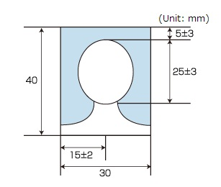

- A photo that shows the applicant him/herself alone.
- A photo of the dimensions specified in the drawing above, excluding the photo's outer border (the dimension of the face refers to the portion from the top of the head [including the hair] to the lower end of the chin).
- The person should face squarely to the front and remove hats, caps or head coverings.
- No background or shadows.
- Must be clear.
- Must be taken within one month prior to submission.
- Must be different from the one on your passport.

